Data Technician
Week 2 Workbook
Tableau and Power BI

Day 3: Task 1
Please complete PL-300T00-A-Lab-02-LA] Clean, transform, and load data in Power BI
on XtremeLabs. Once complete, paste a print screen below and in the collaboration board.
- Visit https://labs.xtremelabs.io/
- Sing into your profile
- Go to View Labs
- Launch and complete PL-300T00-A-Lab-02-LA] Clean, transform, and load data in Power BI.

“Teaching is the best way to learn, so please listen out for support requests from the class and we’ll work through the challenges together”

Paste your completed lab here | 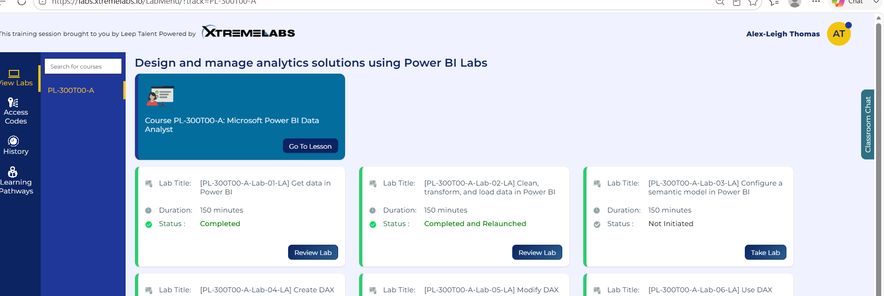

Day 3: Task 2 (Optional)

- Explore Power BI course on DataCamp. Introduction to Power BI

Once complete, publish your report in Power BI service and paste a print screen below and share with your trainer.

Paste your completed lab here

Day 4: Task 1

Please complete [PL-300T00-A-Lab-08-LA] Design Power BI reports on XtremeLabs. Once complete, paste a print screen below and in the collaboration board.
- Visit https://labs.xtremelabs.io/
- Sing into your profile
- Go to View Labs
- Launch and complete [PL-300T00-A-Lab-08-LA] Design Power BI reports.
“Teaching is the best way to learn, so please listen out for support requests from the class and we’ll work through the challenges together”

Paste your completed lab here | 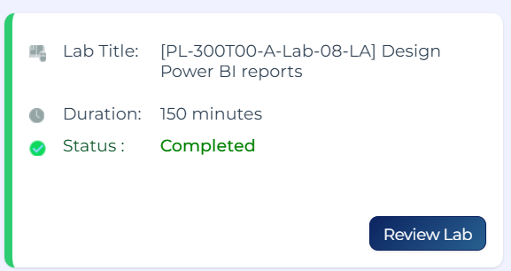

Day 4: Task 2

Please complete [PL-300T00-A-Lab-04-LA] Create DAX calculations in semantic models on XtremeLabs. Once complete, paste a print screen below and in the collaboration board.
- Visit https://labs.xtremelabs.io/
- Sing into your profile
- Go to View Labs
- Launch and complete PL-300T00-A-Lab-04-LA] Create DAX calculations in semantic models.

“Teaching is the best way to learn, so please listen out for support requests from the class and we’ll work through the challenges together”

Paste your completed lab here | 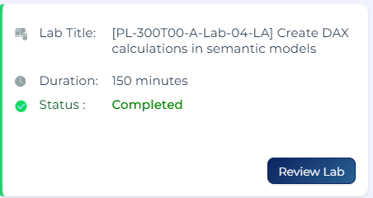

Day 4: Task 3 (Optional)

Please complete [PL-300T00-A-Lab-03-LA] Configure a semantic model in Power BI. on XtremeLabs. Once complete, paste a print screen below and in the collaboration board.
- Visit https://labs.xtremelabs.io/
- Sing into your profile
- Go to View Labs
- Launch and complete [PL-300T00-A-Lab-03-LA] Configure a semantic model in Power BI.

“Teaching is the best way to learn, so please listen out for support requests from the class and we’ll work through the challenges together”

“Teaching is the best way to learn, so please listen out for support requests from the class and we’ll work through the challenges together”

Paste your completed lab here | 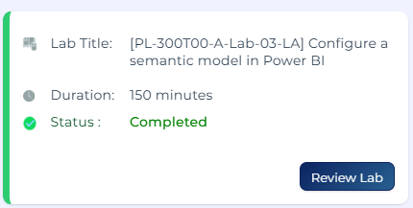

Course Notes

It is recommended to take notes from the course, use the space below to do so, or use the revision guide shared with the class:

Additional Resources to learn and Practice

- Full Beginner Project in Tableau | Tableau Tutorials for Beginners
- Learn Tableau Basic Calculations (Calculated Fields) in Tableau (with 10+ examples) | Part 1
- Tableau Hands-on Challenges Trailmix | Salesforce Trailhead
- Introduction to Tableau - DataCamp Learn
- Creating Dashboards in Tableau - DataCamp Learn
- Sample Data | Tableau Public
- How-To Videos | Tableau Public
- Power BI Cheat Sheet | DataCamp
- Introduction to DAX in Power BI - DataCamp Learn
- Data Visualization in Power BI - DataCamp Learn
- PL 300 Course on MS Learn. Course PL-300T00-A: Design and manage analytics solutions using Power BI - Training | Microsoft Learn This is an intermediate course.

END OF WORKBOOK

Please check through your work thoroughly before submitting and update the table of contents if required.

Please send your completed work booklet to your trainer.

